

William Ford C of E
Junior School

Teaching and Learning Policy

To be reviewed: Every two years
Date of last review: Autumn 2020
Date of next review: Autumn 2022
Ratified by Governing Body:

Signed by Chair of Governors:

Our school vision is
Learning from Jesus Christ, the Prince of Peace, to work diligently, act generously and live at peace with everyone.

Psalm 34:14 - Seek peace and pursue it.

How our vision applies to this policy
Teaching and learning is at the heart of our school; an engaging curriculum not only supports children to work diligently but ensures classrooms are peaceful, happy environments. Our policy outlines our rationale for teaching and learning and sets clear guidance for staff on ensuring not only academic excellence but spiritual, physical, cultural and emotional development for all pupils at William Ford School in line with our vision and values.

Rationale
This policy aims to ensure that every child in our school is provided with high quality learning experiences in order that they may reach their maximum potential in academic, sporting, spiritual, social and moral areas of life. We believe in the concept of lifelong learning and the notion that learning should be a rewarding and enjoyable experience for everyone. Through our teaching we aim to equip children with the skills, knowledge and understanding necessary to work diligently and be able to make informed choices about the important things in their lives.

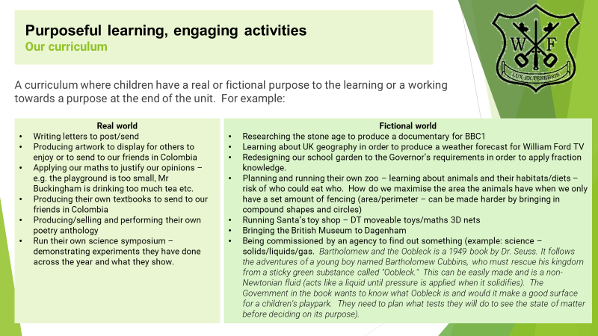

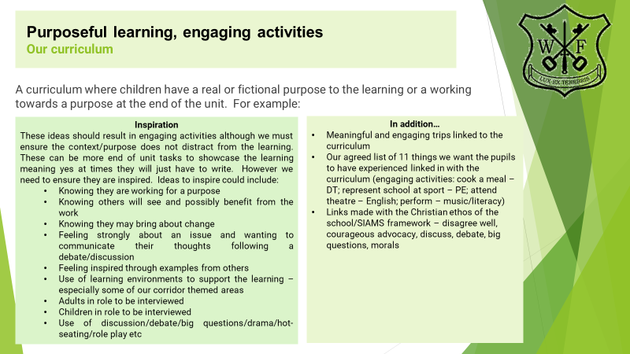

Aim
This teaching and learning policy is intended to promote consistency, high standards and achievement. We aim to provide a caring, supportive and stimulating environment with high quality teaching through which to foster: -

- A positive work ethic encouraging diligence and an enquiring mind which wants to learn more each day
- A high level of literacy and numeracy
- A deeper understanding of the world
- Debate, argue and disagree well
- An understanding of what it means to be caring citizens of the future
- Striving for peace, good manners and good behaviour
- Independence, confidence and co-operation with others
- Imagination and creative expression through a wide range of media
- Pride in achievement and a desire to succeed
- Equality of opportunity for all
- An understanding of the key concepts of Christianity and other world religions

Effective teaching
At William Ford we employ a variety of teaching styles which are appropriate to the situation. When teaching we focus on motivating children and building on their knowledge, skills and understanding by providing a real or fictional purpose to their learning. We use detailed curriculum plans to guide our teaching. These set out the aims, objectives and details of what is to be taught.

We believe children learn effectively when the teacher provides: -

- Shared objectives which are understood by the pupils
- Effective modelling of expectations
- Thoroughly prepared lessons
- Development of vocabulary
- Opportunities to ask ‘Big Questions’
- Lessons where children’s previous learning and interests are built upon
- Clear expectations of what pupils should achieve by the end of the lesson
- Appropriate pace to the lesson
- Thinking time before answering questions
- Opportunities to review and reflect on the learning
- Open-ended, thought provoking, challenging questioning of the children
- Lessons where pupils’ understanding is developed through active, practical and first-hand experience
- Lessons involving individual and collaborative discussion, exploration questioning, prediction, investigation and environment to disagree well
- Support and challenge for the learning of pupils with different levels of attainment
- Developmental feedback and constructive criticism of pupil’s work
- Appropriate use of ICT

We base our teaching on our knowledge of the children’s level of attainment. Our prime focus is to further develop their knowledge and skills. We strive to ensure that all tasks set are appropriate to each child’s level of ability through high quality and effective classroom teaching. We have high expectations of all children and believe they should be included in the full range of educational opportunities.

We begin our units within the foundation subject curriculum with a ‘Big Question’ that links to the Christian ethos of the school and encourages deeper thought and reflection around a topic, including the consideration of scripture. This also encourages healthy discussion and debate, supporting children to disagree well.

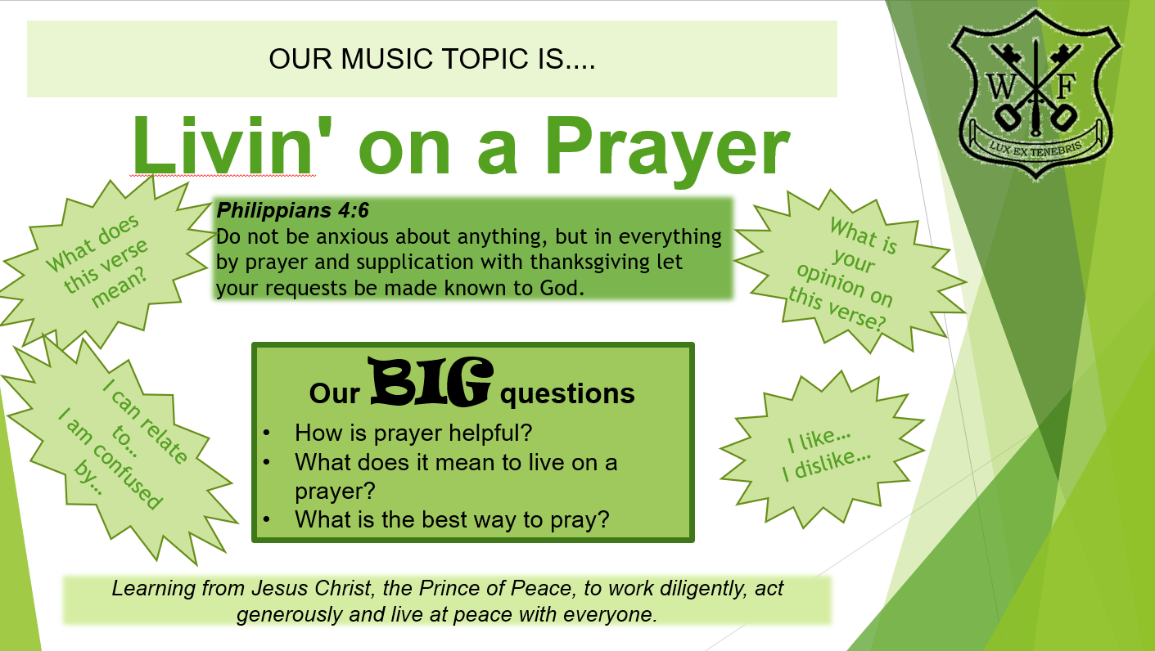

All teachers endeavour to establish positive working relationships with the children they are teaching. We treat them fairly and give them equal opportunity to take part in class activities. All teachers follow the school policy with regard to discipline and classroom management. We praise pupils for good effort and, by doing so, help to build positive attitudes towards learning in general. We insist on good order and behaviour at all times. When children misbehave we follow the guidelines for sanctions as outlined in our school Behaviour Policy.
Learning Support Assistants add value to what teachers do and are deployed in a variety of ways: -
- Deliver high quality one to one and small group support using structured, evidenced based interventions
- Help support and develop independent learning skills
- Help support with displays and learning environment to celebrate and develop pupils’ learning
All teachers meet with their line manager annually to discuss their performance management. Staff regularly reflect on their strengths and weaknesses and plan their professional development needs accordingly.

Effective learning
We acknowledge that people learn in many different ways by sound, sight and use of all senses. We also recognise the need to develop strategies that allow children to learn in the ways that best suit them. These include: -

- Investigation and problem solving
- Research and enquiry
- Purposeful and engaging
- Group work
- Paired work
- Project work
- Independent work
- Whole class work
- Questioning
- Use of ICT
- Visits to places of educational interest
- Creative activities
- Watching film or responding to musical or recorded material
- Debating and disagreeing well, role play and oral presentation
- Designing and making things
- Participation in physical activity
- Reflecting upon what has been learned

We encourage children to take responsibility for their own learning, to be involved as far as possible in reviewing the way they learn and reflect upon this, what helps them learn and what makes it difficult. Planned plenary sessions at the end of lessons are used to review the key learning objectives and to assess the level of understanding. Targets are set at regular intervals to ensure pupils are clear as to how to improve.

A diligent learner is one who: -

- Is self-motivated and works diligently
- Is not deterred by mistakes but sees this as an opportunity to adapt and learn
- Enjoys learning situations
- Raises and answers questions
- Can discuss own work and make comparisons with previous work
- Is able to speak to a variety of audiences about their work
- Displays sustained interest
- Adjusts to different learning situations
- Understands the purpose of work given and builds on previous knowledge, skills and experience
- Shows perseverance
- Adapts to different teaching and learning styles
- Displays good work habits e.g. care in the presentation of work
- Regulates and moderates own behaviour
- Is willing to accept feedback about own work and act upon suggestions
- Values and respects the contributions of others

Children requiring special provision
The curriculum, along with effective teaching and learning, is designed to provide access and opportunity for all children within our care. If we believe it necessary to adapt the curriculum to meet the needs of individual children then we do so in consultation with parents. This may include children who have specific learning needs or children with English as an additional language. See SEND and Equal Opportunities policies.

Behaviour for learning
Staff at William Ford maintain that a positive learning environment occurs when children, staff, parents and governors seek peace, act generously and feel secure and safe. In such a way everyone is able to work diligently and feel they are able to take risks to enhance their own learning. See Behaviour Policy.

Learning environment
The school believes that the purpose of display is to support pupils’ learning. This is achieved in a variety of ways: -

- Working walls
- Modelled examples
- Interactive displays
- Celebrates and makes connections to the Christian ethos of the school
- Posing questions to stimulate discussion
- Word lists
- Key, subject specific vocabulary
- Key ideas
- Information posters/colourful stimulus
- Timelines
- Celebrating success/good work
- Exemplar materials
- Targets and aims
- Agreed class rules
- Timetables/rotas/monitors

Displays in the school should be used to create an attractive and stimulating environment. See Learning Environment Policy. The learning environment should be: -

- Challenging and stimulating
- Relevant to current learning
- Support Christian ethos and vision of the school
- Peaceful and calm
- Well organised
- Well resourced
- Happy and caring
- Encouraging and appreciative
- Provide equality of opportunity for all

Monitoring of Teaching and Learning
William Ford has a meaningful system to monitor and feedback the effectiveness of teaching and learning. Throughout the year there are regular lesson observations, work scrutinies, pupil discussions and learning walks. These can be carried out by the Headteacher and the senior leadership team, year group leaders and subject leaders. Monitoring can also be undertaken by external visiting Headteachers and consultants.

Assessment for learning
We believe that effective assessment of pupils’ work provides valuable information to improve teaching and learning. We give our children regular and effective feedback on their learning so that they understand what it is they need to do to ensure greater understanding and progression. We use information collected from assessments to allow us to reflect and inform future planning. Examples of formative assessments that are used in the classroom are: -

- Ask effective questions
- Effective feedback
- Ask students to reflect
- Use quizzes
- Ask children to summarize
- Response cards
- Misconception check: Present students with a common misconception about a concept you’re covering. Ask them if they agree or disagree and then have them explain their reasoning.
- Peer assessment
- Self-assessment

Pupil code of conduct
Children need clear and consistent guidance and rules in order to meet the high expectations we have of them. These need to be implemented and supported fairly and consistently by everyone. It is the responsibility of every member of staff to ensure they follow the school’s behaviour policy to achieve this. We have a code of conduct that sets out our expectations for behaviour and learning, which helps to create an environment of mutual respect and high achievement. At William Ford…

- We are ready to learn and achieve
- We work purposefully and diligently in all our lessons
- We uphold the vision and values of the school
- We always try our hardest and do our best
- We do not disrupt other pupils’ learning
- We are courteous, polite, honest and friendly
- We listen carefully to others
- We seek peace and pursue it when resolving arguments
- We walk quietly and safely around the school
- We keep our school neat and tidy

Celebrating achievement
Social, physical, creative and academic achievements are celebrated in many ways as an on-going process in all aspects of school life to encourage self-esteem such as: -

- Verbal or written praise by teachers, peers, Headteacher
- Displays of work
- Star of the week
- Opportunities to perform or share within a class, year group or whole school gathering
- The awarding of stickers, merit points and certificates
- Review of achievements with child
- Reporting to parents at consultations/written reports

For more on this, see the Behaviour for Learning Policy.

Links with other policies

- Behaviour for Learning
- SEND
- Marking and Feedback
- Learning Environments
- Equal Opportunities
- Curriculum

Monitoring this policy
Our governors support, monitor and review the school’s policies on teaching and learning. In particular they: -

- Ensure that the school building is effective in supporting successful teaching and learning
- Ensure that the school building and premises comply with health and safety regulations
- Monitor how effective teaching and learning strategies are in terms of raising pupil attainment
- Monitor the effectiveness of teaching and learning policies through the school’s self-review processes. These include the Headteacher’s Report to Governors and the Self Evaluation Form.

APPENDIX 1 – Teacher Standards

Part One: Teaching
A teacher must:
1. Set high expectations which inspire, motivate and challenge pupils
- establish a safe and stimulating environment for pupils, rooted in mutual respect
- set goals that stretch and challenge pupils of all backgrounds, abilities and dispositions
- demonstrate consistently the positive attitudes, values and behaviour which are expected of pupils.
2. Promote good progress and outcomes by pupils
- be accountable for pupils’ attainment, progress and outcomes
- be aware of pupils’ capabilities and their prior knowledge, and plan teaching to build on these
- guide pupils to reflect on the progress they have made and their emerging needs
- demonstrate knowledge and understanding of how pupils learn and how this impacts on teaching
- encourage pupils to take a responsible and conscientious attitude to their own work and study.
3. Demonstrate good subject and curriculum knowledge
- have a secure knowledge of the relevant subject(s) and curriculum areas, foster and maintain pupils’ interest in the subject, and address misunderstandings
- demonstrate a critical understanding of developments in the subject and curriculum areas, and promote the value of scholarship
- demonstrate an understanding of and take responsibility for promoting high standards of literacy, articulacy and the correct use of standard English, whatever the teacher’s specialist subject
- if teaching early reading, demonstrate a clear understanding of systematic synthetic phonics
- if teaching early mathematics, demonstrate a clear understanding of appropriate teaching strategies.
4. Plan and teach well-structured lessons
- impart knowledge and develop understanding through effective use of lesson time
- promote a love of learning and children’s intellectual curiosity
- set homework and plan other out-of-class activities to consolidate and extend the knowledge and understanding pupils have acquired
- reflect systematically on the effectiveness of lessons and approaches to teaching
- contribute to the design and provision of an engaging curriculum within the relevant subject area(s).
5. Adapt teaching to respond to the strengths and needs of all pupils
- know when and how to differentiate appropriately, using approaches which enable pupils to be taught effectively
- have a secure understanding of how a range of factors can inhibit pupils’ ability to learn, and how best to overcome these
- demonstrate an awareness of the physical, social and intellectual development of children, and know how to adapt teaching to support pupils’ education at different stages of development
- have a clear understanding of the needs of all pupils, including those with special educational needs; those of high ability; those with English as an additional language; those with disabilities; and be able to use and evaluate distinctive teaching approaches to engage and support them.
6. Make accurate and productive use of assessment
- know and understand how to assess the relevant subject and curriculum areas, including statutory assessment requirements
- make use of formative and summative assessment to secure pupils’ progress
- use relevant data to monitor progress, set targets, and plan subsequent lessons
- give pupils regular feedback, both orally and through accurate marking, and encourage pupils to respond to the feedback.
7. Manage behaviour effectively to ensure a good and safe learning environment
- have clear rules and routines for behaviour in classrooms, and take responsibility for promoting good and courteous behaviour both in classrooms and around the school, in accordance with the school’s behaviour policy
- have high expectations of behaviour, and establish a framework for discipline with a range of strategies, using praise, sanctions and rewards consistently and fairly
- manage classes effectively, using approaches which are appropriate to pupils’ needs in order to involve and motivate them
- maintain good relationships with pupils, exercise appropriate authority, and act decisively when necessary.
8. Fulfil wider professional responsibilities
- make a positive contribution to the wider life and ethos of the school
- develop effective professional relationships with colleagues, knowing how and when to draw on advice and specialist support
- deploy support staff effectively
- take responsibility for improving teaching through appropriate professional development, responding to advice and feedback from colleagues
- communicate effectively with parents with regard to pupils’ achievements and well-being.
Part Two: Personal and professional conduct
A teacher is expected to demonstrate consistently high standards of personal and professional conduct. The following statements define the behaviour and attitudes which set the required standard for conduct throughout a teacher’s career.
- Teachers uphold public trust in the profession and maintain high standards of ethics and behaviour, within and outside school, by:
- treating pupils with dignity, building relationships rooted in mutual respect, and at all times observing proper boundaries appropriate to a teacher’s professional position
- having regard for the need to safeguard pupils’ well-being, in accordance with statutory provisions
- showing tolerance of and respect for the rights of others
- not undermining fundamental British values, including democracy, the rule of law, individual liberty and mutual respect, and tolerance of those with different faiths and beliefs
- ensuring that personal beliefs are not expressed in ways which exploit pupils’ vulnerability or might lead them to break the law.
- Teachers must have proper and professional regard for the ethos, policies and practices of the school in which they teach, and maintain high standards in their own attendance and punctuality.
- Teachers must have an understanding of, and always act within, the statutory frameworks which set out their professional duties and responsibilities.

The full document on the Professional standards for teachers can be found here: -

https://assets.publishing.service.gov.uk/government/uploads/system/uploads/attachment_data/file/665520/Teachers__Standards.pdf

APPENDIX 2 – Teaching Assistants Standards

Personal and professional conduct – In order for teaching assistants to provide effective support to teachers and pupils, they need to be clear about their role and responsibilities and how these fit within the wider structure of the school. In the same way as teachers, teaching assistants operate in a position of trust and are seen by pupils as role models. They should be able to maintain proper boundaries with pupils and their behaviours should reflect this responsible position.
Knowledge and understanding – Teaching assistants should have sufficient knowledge and skills to help teachers support pupils in achieving their maximum potential. School leaders are best placed to make judgements about the type and level of knowledge and skills that individual teaching assistants need, as this will vary according to job role. This could include: subject knowledge; specialist skills and knowledge to support pupils with special educational needs or disabilities; knowledge of the curriculum; pedagogical knowledge; behaviour management strategies.
Teaching and learning – An important role of a teaching assistant is to support the teacher in ensuring the best possible outcomes for all pupils. The standards in this theme recognise that teaching assistants work under the supervision of a teacher in accordance with arrangements made by the headteacher of the school. Schools should refer to the EEF guidance report (see Further information) for ‘relevant strategies to support the work of the teacher’.
Working with others – Teaching assistants work with other professionals, parents, carers and outside agencies as well as with pupils themselves. Although other themes require teaching assistants to work collaboratively with others, these qualities and skills were considered so important and distinctive to the role as to merit their own theme.
Personal and professional conduct

Teaching assistants should uphold public trust in the education profession by:
- Having proper and professional regard for the ethos, policies and practices of the school in which they work as professional members of staff.
- Demonstrating positive attitudes, values and behaviours to develop and sustain effective relationships with the school community.
- Having regard for the need to safeguard pupils’ well-being by following relevant statutory guidance along with school policies and practice.
- Upholding values consistent with those required from teachers by respecting individual differences and cultural diversity.
- Committing to improve their own practice through self-evaluation and awareness.
Knowledge and understanding

Teaching assistants are expected to:
- Share responsibility for ensuring that their own knowledge and understanding is relevant and up to date by reflecting on their own practice, liaising with school leaders, and identifying relevant professional development to improve personal effectiveness.
- Take opportunities to acquire the appropriate skills, qualifications, and/or experience required for the teaching assistant role, with support from the school/employer.
- Demonstrate expertise and skills in understanding the needs of all pupils (including specialist expertise as appropriate) and know how to contribute effectively to the adaptation and delivery of support to meet individual needs.
- Demonstrate a level of subject and curriculum knowledge relevant to their role and apply this effectively in supporting teachers and pupils.
- Understand their roles and responsibilities within the classroom and whole school context recognising that these may extend beyond a direct support role.

Teaching and learning

Teaching assistants are expected to:
- Demonstrate an informed and efficient approach to teaching and learning by adopting relevant strategies to support the work of the teacher and increase achievement of all pupils including, where appropriate, those with special educational needs and disabilities.
- Promote, support and facilitate inclusion by encouraging participation of all pupils in learning and extracurricular activities.
- Use effective behaviour management strategies consistently in line with the school’s policy and procedures.
- Contribute to effective assessment and planning by supporting the monitoring, recording and reporting of pupil performance and progress as appropriate to the level of the role.
- Communicate effectively and sensitively with pupils to adapt to their needs and support their learning.
- Maintain a stimulating and safe learning environment by organising and managing physical teaching space and resources.

Working with others

Teaching assistants are expected to:
- Recognise and respect the role and contribution of other professionals, parents and carers by liaising effectively and working in partnership with them.
- With the class teacher, keep other professionals accurately informed of performance and progress or concerns they may have about the pupils they work with.
- Understand their responsibility to share knowledge to inform planning and decision making.
- Understand their role in order to be able to work collaboratively with classroom teachers and other colleagues, including specialist advisory teachers.
- Communicate their knowledge and understanding of pupils to other school staff and education, health and social care professionals, so that informed decision making can take place on intervention and provision.
The full document on the Professional standards for teaching assistants can be found here: -
https://www.unison.org.uk/content/uploads/2016/06/Teaching-Assistant-Professional-Standards.pdf

